|  |  |
| --- | --- |
| *URSI-RCRS 2024, ARIES/GEHU, Bhimtal, India, 22 - 25 October, 2024* | *..\..\..\..\APSMAG\URSIblueHi.tif* |

**Construction and Observational Results of The Bavdhan 21cm Small Radio Telescope**

Parth D. Darade(1)

(1) SCI-COM Software India Pvt. Ltd. e-mail: parth.d.darade@gmail.com

**Abstract**

Technological advancements in the last decade have made radio astronomy accessible to even amateurs. Software Defined Radio (SDR) technology is revolutionising the field by shifting processing tasks from hardware to software, allowing more flexibility. The discovery of Digital Video Broadcast-Terrestrial (DVB-T) receivers to be used as general-purpose Software Defined Radios (SDR) significantly increased the availability of radio equipment even to amateurs.

Radio astronomy is a field which is grateful to amateurs for their pioneering work. Making radio astronomy more accessible will invite more innovators in the field. The 21 cm neutral-hydrogen line is a key frequency for observing the universe, providing valuable information about the structure and movement of the Milky Way galaxy.

This report summarises the radio telescope’s construction, calibration and observational results obtained by the radio telescope. The telescope was constructed on a low budget using off-the-shelf and cheap hardware. The project aimed to successfully build a radio telescope using RTL2832u-based DVB-T tuners to observe λ = 21 cm radio emissions, especially from the Milky Way galaxy.

1. The 21 cm Radio Emissions

The 21 cm neutral-hydrogen line is one of the most popular frequencies to observe the universe among radio astronomy enthusiasts. Apart from being relatively straightforward to observe and hydrogen being abundant across the universe, it provides information about the structure and movement of the Milky Way galaxy. [1]

2. Digital Video Broadcast-Terrestrial (DVB-T) Receiver as General-Purpose Software Defined Radio

It was discovered that the mass-produced, reasonably priced DVB-T receivers were general-purpose SDRs while attempting to convert the driver for DVB-T receivers to a Linux operating system in 2010 [2]. Realtek RTL2832U-based DVB-T receivers popularly known as ‘RTL-SDRs’, are popular among students, amateurs and professionals alike due to their affordability, ease of use and flexibility. They offer a frequency range of 24 – 1766 MHz, bandwidth up to 2.4 Msamples/s and 8-bit resolution [2]. The USB interface of these receivers allows seamless integration with computers. As the 21 cm line frequency at ~1420MHz comes under the frequency range of R820-T2/R860 tuner-based RTL-SDRs, It was an excellent choice for this project.

3. Telescope Construction

The radio telescope was constructed using off-the-shelf and affordable components. The main components include:

* **Parabolic Reflector Dish:** An old C-band satellite TV dish with a diameter exceeding 2.4 meters, with a f ratio of 0.41
* **SDR:** RTL-SDR blog v3 USB dongle containing the RTL2832u demodulator and R860 tuner.

* **LNA+BPF:** A two-stage low-noise amplifier with an inbuilt SAW filter between both stages, specifically the Nooelec SAWBird+ HI LNA. This LNA boosts the incoming signals enough to be detected by the SDR, but it also prevents interference by integrating a bandpass filter centred around 1420MHz.
* **Feedhorn:** A simple circular waveguide horn with a Kumar choke [3] also known as the VE4MA horn [4] was chosen for its radiation pattern that minimises spillover and proven design [5]. It was crafted by folding sheet metal into the appropriate shape, joints were achieved by crimping sheets together making a firm fit that maintained electrical continuity.

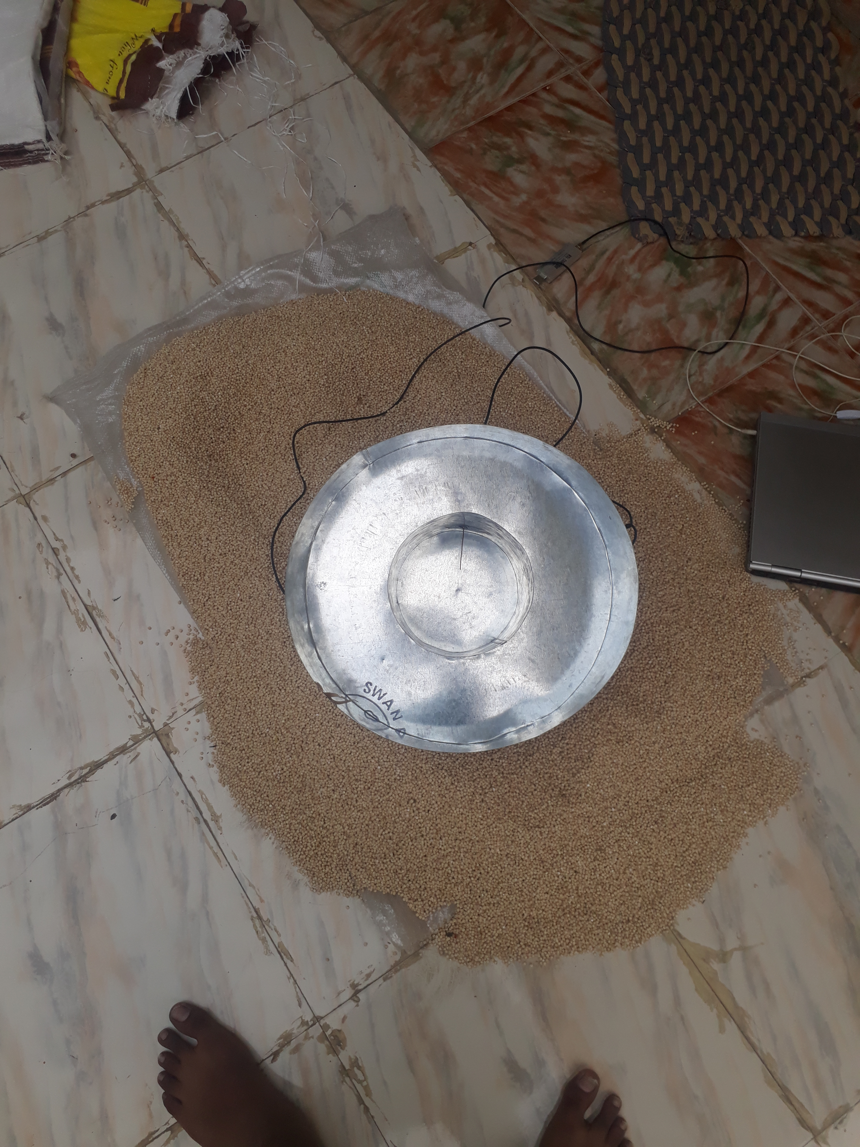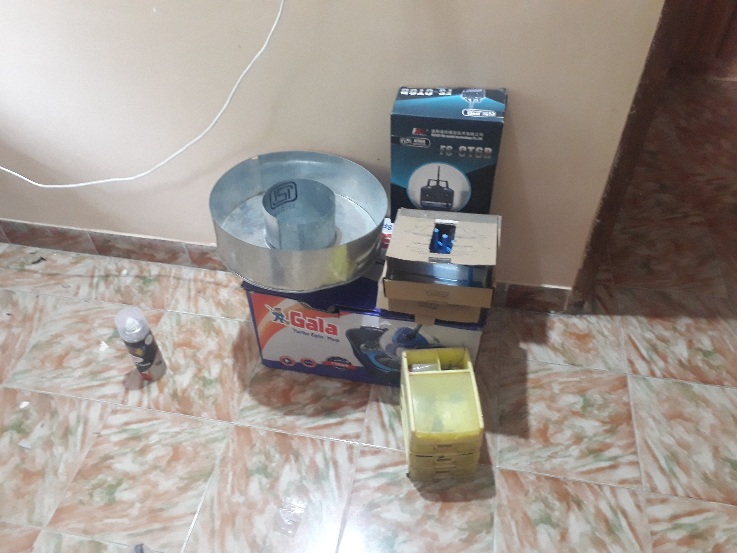

**Figure 1** The fabricated VE4MA Feedhorn.

**Figure 2** is a block diagram explaining the flow of the system.

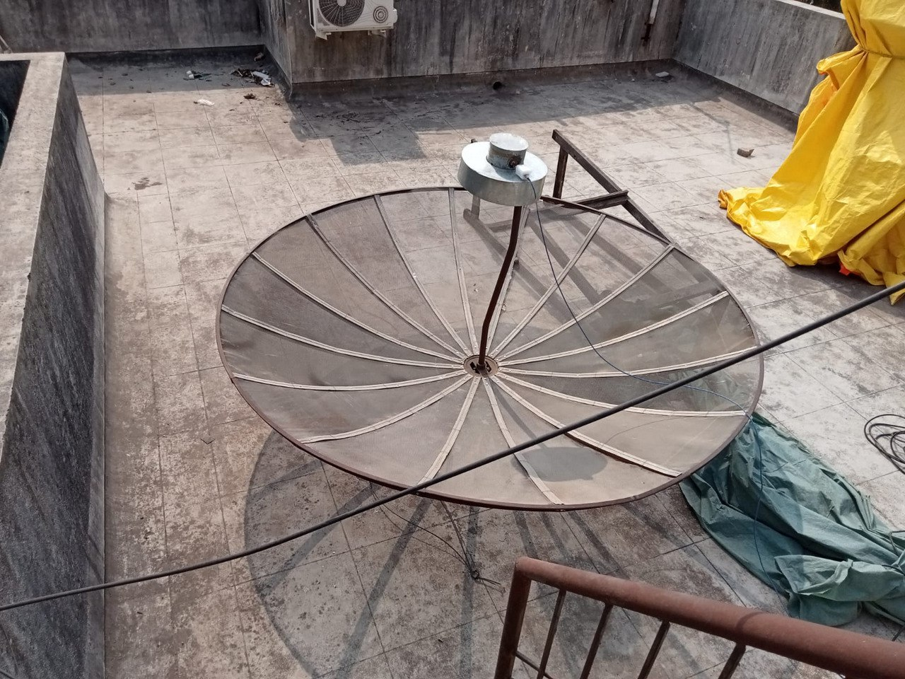

**Figure 3** The setup consisting of the dish the feedhorn and the LNA balanced on bricks. A RG-58 coaxial cable runs from the feed to the RTLSDR indoors.

4. Software and Calibration

The RTL-SDR was controlled using VIRGO open-source software which in addition to data acquisition, also takes care for calibration of the telescope, and carrying out analysis of the recorded samples. [6] Calibration involved recording a relatively blank portion of the sky to obtain the bandpass shape. This recording was used to eliminate the bandpass shape caused by the antenna as well as the tuner. The VIRGO software outputs plots containing signal-to-noise ratio (SNR) vs. frequency averaged and calibrated spectrum. The calibrated spectrum plot is where the software uses the calibration spectrum recorded earlier to eliminate the bandpass shape and display a much more contrasting plot.

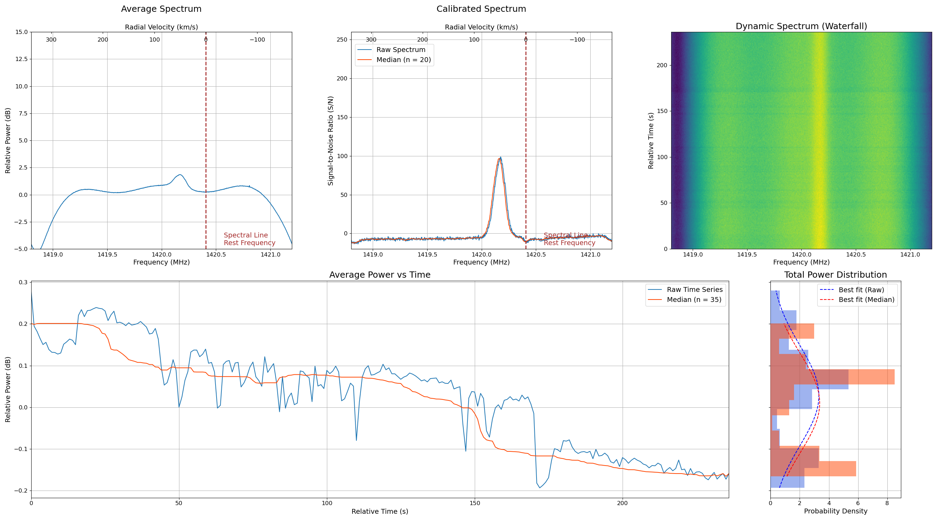

**Figure 4** A VIRGO result plot. (2024 May 29 - 12:48 UTC, Looking at l=191 degrees and b=1.2 deg)

5. Observation

Observations were conducted over an 18-hour drift scan, while the telescope was pointed towards the zenith. The telescope captured the Milky Way plane passing through the beam twice, allowing for the detection of HI emissions. Data was recorded for 4 minutes per observation, keeping a 10-minute gap between observations.

6. Results and Analysis

Initial analysis of the VIRGO-generated plots revealed that the telescope was not only successful at detecting the signals from the galaxy but also at distinguishing between the signals originating from clouds travelling at different velocities. The data showed multiple galactic arms and hydrogen clouds, with some peaks indicating motion.

Further analysis of the observed data was done by plotting the mean deviations of the SNR values of frequency bins for each observation on a map. The map revealed significant HI emissions from the Milky Way at 6 hours and 20 hours right ascension, with higher intensities observed towards the galactic centre. These results align with previous findings [7] that contributed to the understanding of the galactic structure.

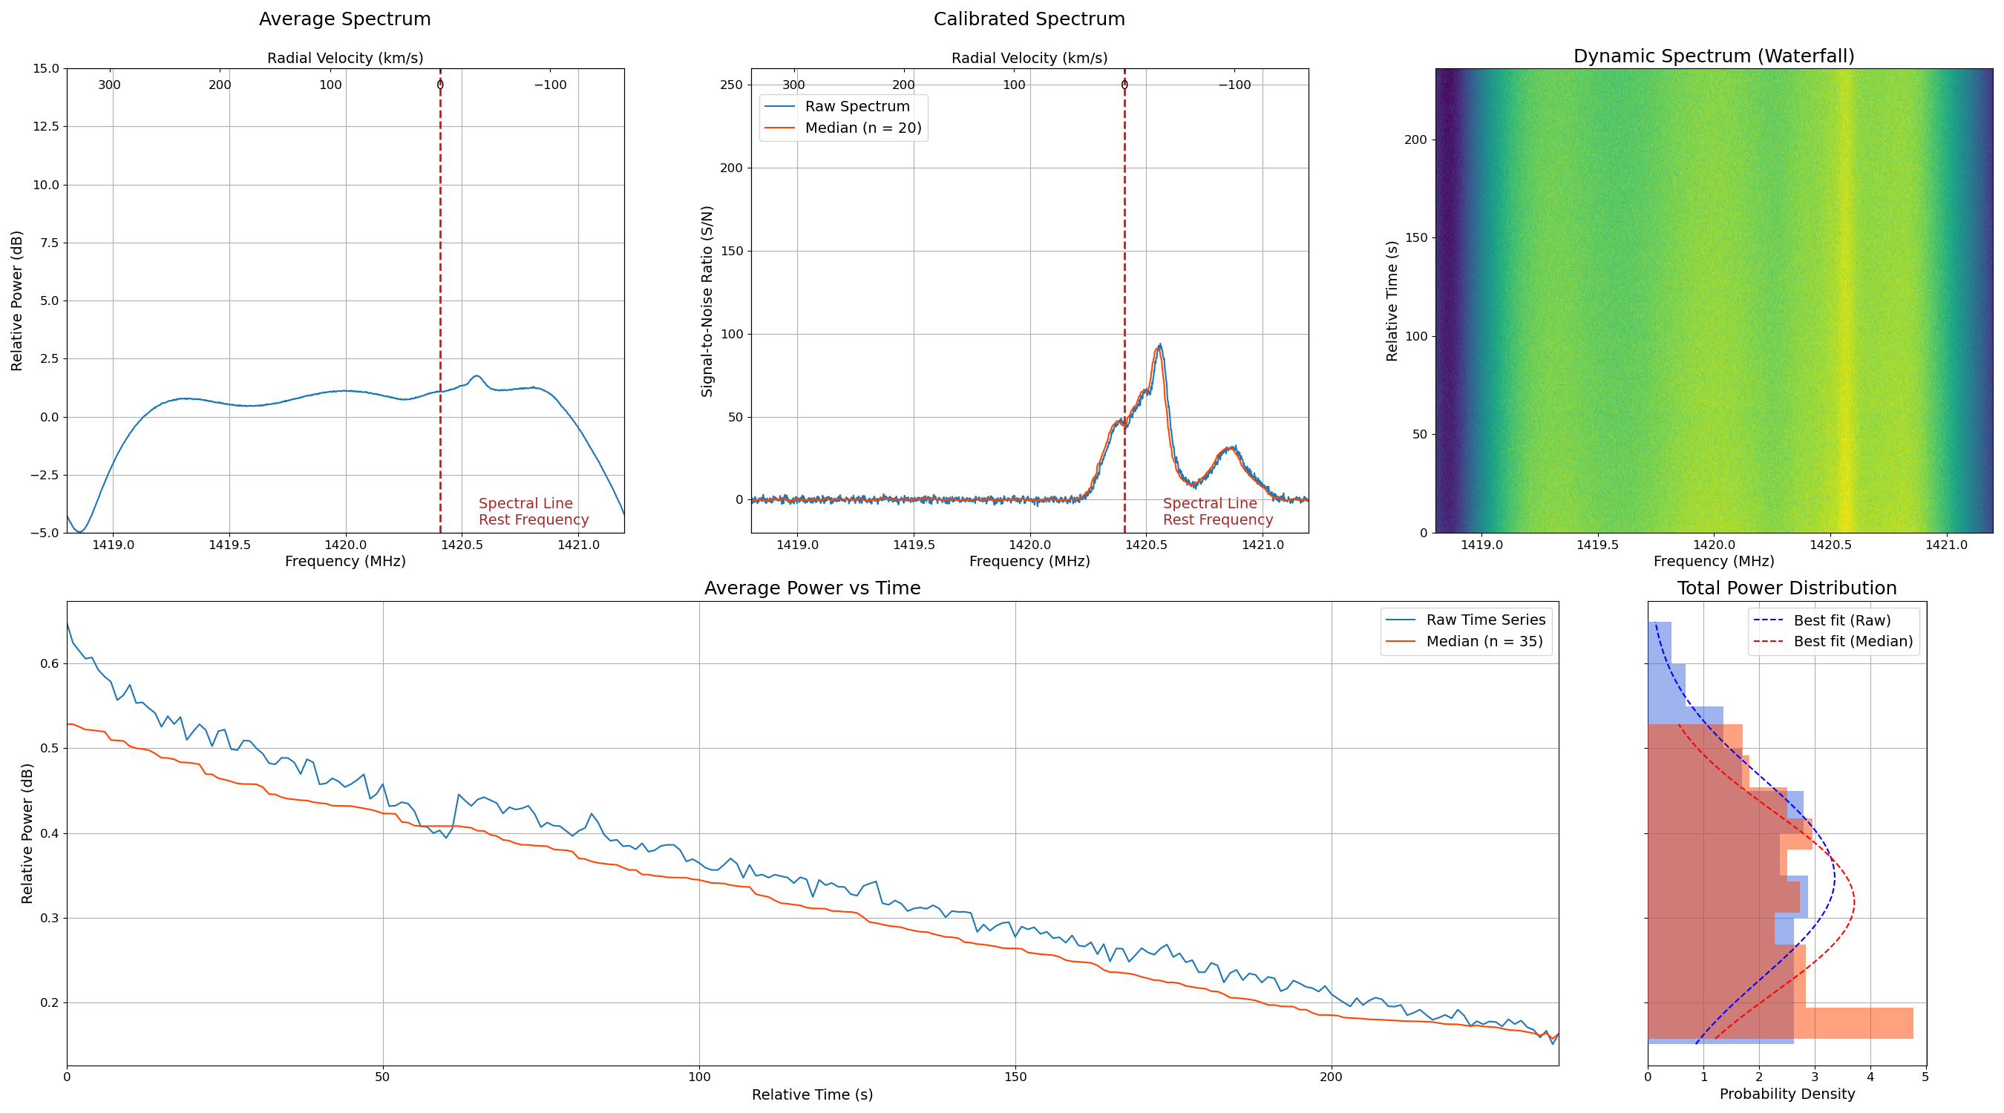

Figure 5 The observed spectrum at l = 53° b= 2° (2024 May 30 01:54 UTC)

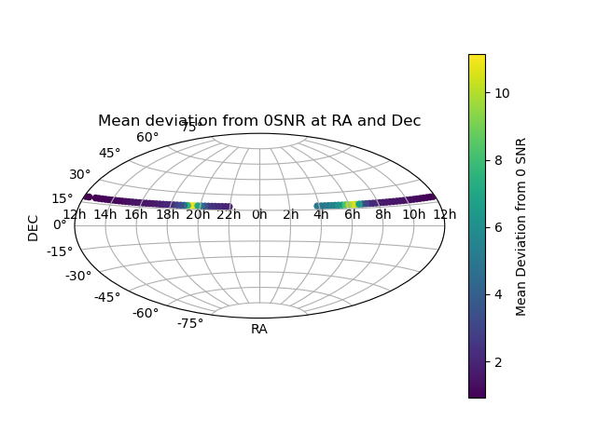

Figure Mean deviations from 0 SNR plotted on a projection of the sky.

7. Conclusion

The construction and observation with the 21 cm radio telescope obtained data successfully on the HI emissions from the Milky Way. The telescope demonstrated good performance in capturing radio signals, providing valuable data for further analysis and experimentation. This project highlights the feasibility of building cost-effective radio telescopes for educational and research purposes, fostering greater interest and understanding in radio astronomy.

**8. Acknowledgements**

P. D. Darade is thankful to VU2VPR Vilas Rabde and Dr. Vishwas Udpikar for granting an appointment as an intern in SCI-COM Software. P. D. Darade is grateful to VU2MSB M.S. Bhagwat for donating the C-Band TV dish for the project. The development of the telescope was assisted by Shyam Agarwal and the SCI-COM mechanical team. Apostolos Spanakis Misirilis deserves a mention for developing the VIRGO software for radio telescopes and assisting in the development by providing his help and support for the software.

9. References

|  |  |
| --- | --- |
| [1] | H. I. Ewen and E. M. Purcell, "Observation of a Line in the Galactic Radio Spectrum: Radiation from Galactic Hydrogen at 1,420 Mc./sec," *Nature,* vol. 168, pp. 356-358, 1951. |
| [2] | S. Markgraf, D. Stonikov and Hoernchen, "Rtl-sdr," Osmocom, [Online]. Available: https://osmocom.org/projects/rtl-sdr/wiki/Rtl-sdr. [Accessed 18 07 2024]. |
| [3] | A. Kumar, "Reduce Cross-Polarization in Reflector-Type Antennas," *Microwaves,* vol. March, pp. 48-51, 1978. |
| [4] | B. Malowanchuk and VE4MA, "Use of Small TVRO Dishes for EME," in *21st Conference of the Central States VHF Society, ARRL*, 1987. |
| [5] | S. Tadeja and V. Matjaž, "A Compact Radio Telescope for the 21 cm Neutral-," *Journal of Microelectronics,* vol. 27, pp. 113- 128, No.2 (2017). |
| [6] | A. Spanakis-Misirlis, C. L. V. Eck and E. Boven, "Virgo: A Versatile Spectrometer for Radio Astronomy," *Journal of Open Source Software,* vol. 6, no. 62, p. 3067, 2021. |
| [7] | P. M. W. Kalberla, W. B. Burton, D. Hartmann, E. M. Arnal, E. Bajaja, R. Morras and W. G. L. Pöppel, "The Leiden/Argentine/Bonn (LAB) Survey of Galactic HI. Final data release of the combined LDS and IAR surveys with improved stray-radiation corrections," *Astronomy and Astrophysics,* vol. 440, no. 2, pp. 775-782, 2005. |